How do we want to structure the level?

1. Be able to find things
   1. Dungeon-generated layout
      1. Node-based generation with exit/entrances connected
      2. We want one floor to have # of nodes => beat miniboss

ARTISTS

1. Need tiles to be able to tessellate
   1. Need to design a series of basic tilesets
      1. Floors, Walls, Pits
   2. Each room has 4 exits
      1. 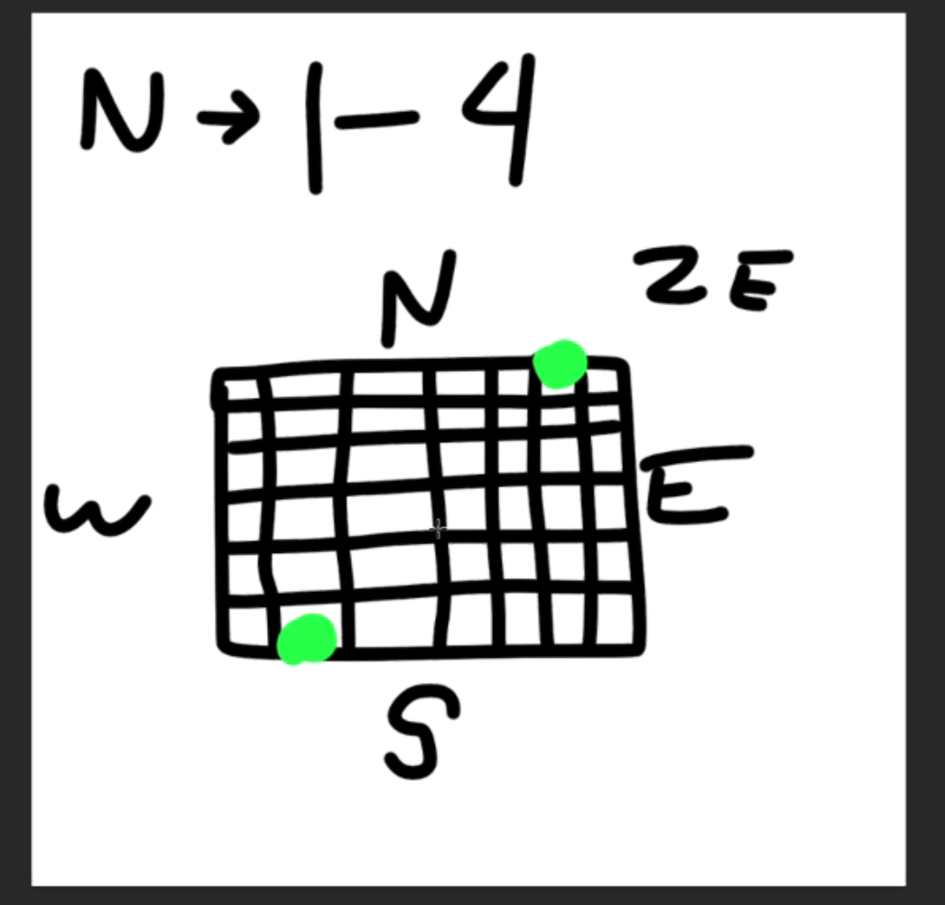
   3. Make these rooms out of tiles
   4. Draw perspective in 3/4th down
2. UI (Buttons)
   1. Title Screen (Empatheseus)
   2. Pause Menu
   3. Settings (remappable UI)
   4. Health

Combat

1. Have set of health points, monsters shoot things and when take hit you lose damage
2. Each shot deals x damage, enemies have x HP

Room Generator